Summer Camps for Children in Urban Slums “A great way for TB advocacy”
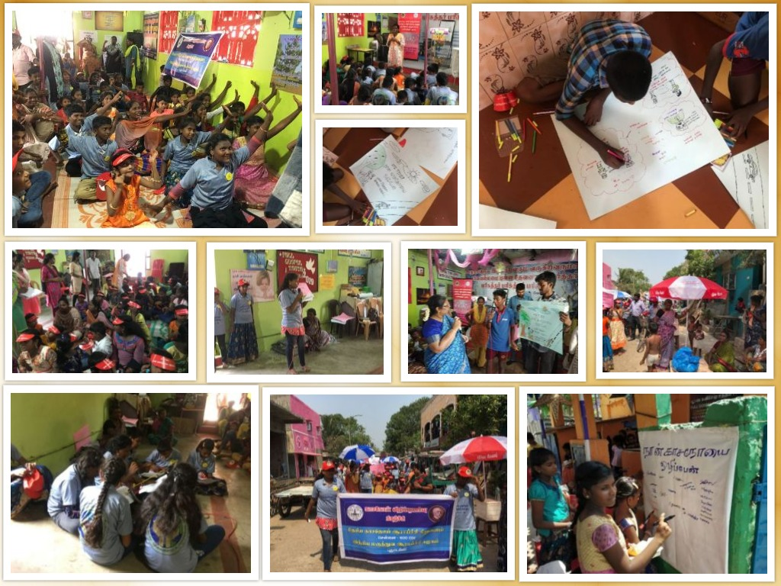
The Department of Social and Behavioural Research (DSBR) is involved in a study on utilization of school children as ambassadors for TB control. Student friendly sensitization programs were held in various city schools for children and 10 school ambassadors from 57 schools each were selected to in turn be TB advocates in their communities. With schools being closed and children at home, the school ambassadors with the team came up with a plan for TB summer camps in different slum communities for children to spread awareness on TB. The first one took off on 11th May 2019 in the Ganesapuram urban slum in Vyasarpadi. The camp facilitated by the school ambassadors along with the NIRT team was a big success for children from the slum communities. This included a skit on TB, painting competitions on TB, interactive discussion on TB and ended with a rally that all the children took through the slum with umbrellas with messages on TB, banners with TB messages and shouting slogans on TB. This was followed by a signature/thumb impression campaign by the children, pledging their commitment to eliminate TB in their communities.

